A
Industrial-Oriented Mini Project On

FITCLUSTER AI – A HYBRID INTELLIGENT FITNESS RECOMMENDATION SYSTEM
(Submitted in partial fulfilment of the requirements for the award of Degree)

BACHELOR OF TECHNOLOGY
In

COMPUTER SCIENCE AND INFORMATION TECHNOLOGY
By

B SHASHANK B CHAITANYA K PRAVEEN
(237R1A3315) (237R1A3329) (237R1A3346)

Under the Guidance of

G. SHANKAR
(Assistant Professor)


DEPARTMENT OF COMPUTER SCIENCE AND INFORMATION TECHNOLOGY
CMR TECHNICAL CAMPUS
UGC AUTONOMOUS
(Accredited by NAAC, NBA, Permanently Affiliated to JNTUH, Approved by AICTE, New Delhi)
Recognized Under Section 2(f) & 12(B) of the UGCAct.1956, Kandlakoya (V), Medchal Road, Hyderabad-501401.
May, 2026.

DEPARTMENT OF COMPUTER SCIENCE AND INFORMATION TECHNOLOGY


CERTIFICATE

This is to certify that the project entitled “FITCLUSTER AI - A HYBRID INTELLIGENCE FITNESS RECOMMENDATION SYSTEM” being submitted b y B.SHASHANK (237R1A3315), B.CHAITANYA (237R1A3329), K.PRAVEEN
(237R1A3346) in partial fulfilment of the requirements for the award of the degree of B.Tech in Computer Science and Information Technology to the Jawaharlal Nehru Technological University Hyderabad, during the year 2025-26.

The results embodied in this thesis have not been submitted to any other
University or Institute for the award of any degree or diploma.

G. Shankar Assistant Professor INTERNAL GUIDE

HoD

Dr. A. Raji Reddy DIRECTOR
Signature of External Examiner

Submitted for viva voice Examination held on

ACKNOWLEDGEMENT
We take this opportunity to express our gratitude to the people who have been instrumental in the successful completion of this project, we take this opportunity to express our profound gratitude and deep regard to our guide G. Shankar, Assistant Professor for his exemplary guidance, monitoring and constant encouragement throughout the project work. The blessing, help and guidance given by him shall carry us a long way in the journey of life on which we are about to embark.

We take this opportunity to extend our heartfelt appreciation to the Project Review Committee (PRC) Coordinators— Dr. J. Narasimharao, Mr. G. Shankar, Mr. Md. Sajid Pasha, Mrs. V. Srisuma, Mr. R. Ravi and Mr. M. Ramesh Babu —for their unwavering support, insightful guidance, and valuable inputs, which played a crucial role in steering this project through its various stages.

Our sincere appreciation also goes to our Head of the Department, for encouragement and continuous support in ensuring the successful completion of our project.

We are deeply grateful to Dr. A. Raji Reddy, Director, for his cooperation throughout the course of this project. Additionally, we extend our profound gratitude to Sri. Ch. Gopal Reddy, Chairman, Smt. C. Vasantha Latha, Secretary and Sri. C. Abhinav Reddy, Vice-Chairman, for fostering an excellent infrastructure and a conducive learning environment that greatly contributed to our progress.

We also acknowledge and appreciate the guidance and assistance provided by the faculty and staff of CMR Technical Campus, whose contributions have been invaluable in bringing this project to fruition.

Lastly, we sincerely thank our families for their unwavering support and encouragement. We also extend our gratitude to the teaching and non-teaching staff of CMR Technical Campus for their guidance and assistance. Their contributions, along with the support of everyone who helped directly or indirectly, have been invaluable in the successful completion of this project.

B.Shashank (237R1A3315) B.Chaitanya (237R1A3329) K.Praveen (237R1A3346)

VISION AND MISSION

INSTITUTE VISION:

To Impart quality education in serene atmosphere thus strive for excellence in Technology and Research.

INSTITUTE MISSION:

- To create state of art facilities for effective Teaching- Learning Process.

- Pursue and Disseminate Knowledge based research to meet the needs of Industry & Society.

- Infuse Professional, Ethical and Societal values among Learning Community.

DEPARTMENT VISION:

To produce technically proficient and skilled graduates in Information Technology and to prepare them to meet the needs of industry and society in a holistic learning environment.

DEPARTMENT MISSION:

- To prepare students with the essential knowledge and contemporary abilities for solving emerging technological problems.

- To train the students on cutting – edge computing facilities with industry interaction to enhance in practical exposure to real world situations.

- To enhance the leadership qualities and team spirit with social values to serve the society.

ABSTRACT

Fitness recommendation systems play a vital role in promoting healthy lifestyles by providing personalized workout and diet plans. However, most existing systems either rely on generic rule-based logic or complex deep learning models that lack transparency and require In recent years, the growing awareness of health and fitness has increased the demand for intelligent systems that can provide personalized workout and diet recommendations. Many existing fitness recommendation systems rely either on static rule-based logic or on complex machine learning and deep learning models. While deep learning-based approaches show promise in certain domains, their effectiveness in personalized fitness planning is limited due to the lack of large, reliable, and continuously evolving user-specific datasets. Fitness recommendations are highly constrained by physiological rules, safety guidelines, and domain expertise, making purely data-driven models unsuitable for many real-world scenarios.

This project presents FitCluster AI, a hybrid intelligent fitness and diet recommendation system that combines rule-based domain knowledge with lightweight machine learning techniques. The system accepts user inputs such as age, gender, height, weight, fitness goal, experience level, available workout time, equipment access, diet preference, adherence level, and recovery capacity. Based on these inputs, the system performs BMI analysis, caloric requirement estimation, and fitness profiling. A clustering- based machine learning module is used to group users into fitness clusters and adjust recommendations based on similarity patterns, rather than generating unsafe or opaque outputs.The application is implemented using a React-based frontend for user interaction and visualization, and a FastAPI-based backend for processing, recommendation generation, and machine learning analysis. The modular architecture allows scalability, transparency, and easy integration with future data sources such as wearable devices.

FIGURE NO | FIGURE NAME | PAGE  NO
Figure 3.1 | Project Architecture of A Rule Based Approach for  Fitness Recommendation System | 11
Figure 3.2 | Dataflow Diagram of A Rule Based Approach for Fitness Recommendation System | 14
Figure 5.1 | GUI/Main Interface of FIT CLUSTER AI- A Hybrid Intelligence of a Fitness Recommendation System | 33
Figure 5.2 | Fitness profile Image of FIT CLUSTER AI- A Hybrid Intelligence of a Fitness Recommendation System | 34
Figure 5.3 | Training setup Image of FIT CLUSTER AI- A Hybrid Intelligence of a Fitness Recommendation System | 34
Figure 5.4 | Lifestyle Image of FIT CLUSTER AI- A Hybrid Intelligence of a Fitness Recommendation System | 35

Figure 5.5 | Generated Diet plan Image of FIT CLUSTER AI- A Hybrid Intelligence of a Fitness Recommendation System | 36
Figure 5.6 | Generated Weekly workout plan Image of FIT CLUSTER AI - A Hybrid Intelligence of a Fitness Recommendation System | 37
Figure 5.7 | workout Form and video of FIT CLUSTER AI - A Hybrid Intelligence of a Fitness Recommendation  System | 38

LIST OF TABLES

TABLE NO | TABLE NAME | PAGE  NO
Table 6.1 | BMI range table category of FIT CLUSTER AI -A Hybrid Intelligence of Fitness Recommendation System | 36
Table 6.2 | BMI rule table of FIT CLUSTER AI - A Hybrid Intelligence of Fitness Recommendation System | 41

TABLE OF CONTENTS
ABSTRACT | i
LIST OF FIGURES | ii
LIST OF TABLES | v
1. INTRODUCTION | 1
1.1 PROJECT PURPOSE | 1
1.2 PROJECT FEATURES | 2
2. LITERATURE SURVEY | 3
2.1 REVIEW OF RELATED WORK | 4
2.2 DEFINITION OF PROBLEM STATEMENT | 6
2.3 EXISTING SYSTEM | 7
2.4 PROPOSED SYSTEM | 8
2.5 OBJECTIVES | 9
2.6 HARDWARE & SOFTWARE REQUIREMENTS | 10
2.6.1 HARDWARE REQUIREMENTS | 10
2.6.2 SOFTWARE REQUIREMENTS | 10
- SYSTEM ARCHITECTURE & DESIGN 11

3.1
3.2
3.3
PROJECT ARCHITECTURE 11
DESCRIPTION 12
DATA FLOW DIAGRAM 13

- IMPLEMENTATION 15

4.1
4.2
ALGORITHMS USED 15
SAMPLE CODE 19

- RESULTS & DISCUSSION 33
- VALIDATION 41

6.1
6.2
INTRODUCTION 41
TEST CASES 41

- CONCLUSION & FUTURE ASPECTS 42

7.1
7.2
PROJECT CONCLUSION 42
FUTURE ASPECTS 43

- BIBLIOGRAPHY 44

8.1
8.2
REFERENCES 44
GITHUB LINK 45

INTRODUCTION

INTRODUCTION

The increasing awareness of health and fitness has led to a growing demand for intelligent systems that can provide personalized exercise and diet recommendations. Traditional fitness plans often fail to consider individual differences such as body composition, lifestyle, recovery ability, and adherence levels. While recent advancements in artificial intelligence have introduced deep learning-based fitness solutions, these systems often suffer from issues such as lack of explainability, high computational cost, and dependency on large datasets.

FitCluster AI addresses these limitations by adopting a hybrid approach, combining deterministic rule-based logic with machine learning-assisted pattern discovery. This ensures that recommendations are both personalized and interpretable, making the system suitable for academic, practical, and real-world use.

PROJECT PURPOSE

The purpose of this project is to design and implement an intelligent fitness recommendation system that:

- Provides personalized workout and diet plans.
- Maintains transparency and explainability.
- Avoids over-dependence on large datasets and deep learning models.
- Can be easily deployed and extended in real-world environments.

PROJECT FEATURES

- Personalized Fitness Profiling: Collects detailed user inputs such as age, gender, height, weight, fitness goal, experience level, available time, equipment, diet preference, adherence, and recovery level.

- Hybrid Recommendation Engine: Combines deterministic rule-based logic with ML- assisted clustering to enhance personalization.

- Workout & Diet Planning: Generates structured weekly workout routines and diet plans aligned with user profiles.

- Explainability Module: Displays both rule-based decisions and ML-assisted insights for transparency.

- Interactive Dashboard: Visualizes BMI, calorie targets, protein goals, training mode, and cluster confidence.

- Scalable API Architecture: Backend implemented using FastAPI, enabling easy integration with web and mobile platforms.

2. LITERATURE SURVEY

.

LITERATURE SURVEY

With the increasing global emphasis on health, wellness, and preventive care, digital fitness and diet recommendation systems have gained significant attention in recent years. The rapid growth of sedentary lifestyles and lifestyle-related diseases has created a demand for personalized fitness solutions that can adapt to individual body characteristics, goals, and daily routines. Traditional fitness guidance methods, such as generic workout charts and diet plans, often fail to address individual variability, leading to poor adherence and suboptimal results. As a result, researchers have explored computational approaches to deliver customized fitness and nutrition recommendations.

Early fitness recommendation systems primarily relied on rule-based expert systems, where predefined rules derived from exercise science and nutritional guidelines were used to generate workout and diet plans. These systems were transparent, safe, and easy to interpret but lacked adaptability and personalization. With advancements in artificial intelligence, researchers began exploring machine learning-based approaches, including clustering and similarity analysis, to group users with similar physical attributes and fitness goals. These methods aimed to enhance personalization while maintaining manageable computational complexity.

More recently, deep learning techniques have been investigated in fitness-related applications, particularly for activity recognition using wearable sensors, posture detection, and video-based exercise analysis. Although deep learning models demonstrate strong performance in pattern recognition tasks, their application in fitness recommendation systems presents several challenges, including the requirement for large labeled datasets, high computational costs, and limited explainability. In many real-world fitness scenarios, user data is sparse, highly variable, and domain-dependent, reducing the practical effectiveness of deep learning-based recommendation models.

.

This literature survey examines existing fitness and diet recommendation systems, focusing on rule-based methods, traditional machine learning techniques, and hybrid approaches. The review highlights the strengths and limitations of these systems, emphasizing the need for a balanced solution that offers personalization, explainability, and practical usability without over-reliance on deep learning models. The findings from existing research motivate the design of the proposed Hybrid Intelligent Fitness Recommendation System, which combines deterministic rule-based logic with lightweight machine learning-assisted analysis.

REVIEW OF RELATED WORK

- Traditional Content Moderation Approaches

Waseem, Z., & Hovy, D. (2016). This paper explores traditional approaches to content moderation using supervised machine learning combined with manually engineered features such as n-grams and keyword-based filters. The authors rely on labeled Twitter data to classify offensive and non-offensive content. The model uses linguistic cues and predefined rules, reflecting early moderation systems that depend heavily on feature engineering. While effective for structured detection, these methods struggle with context, sarcasm, and evolving language patterns. The study highlights limitations in scalability and adaptability, especially when new forms of harmful content emerge. It demonstrates that traditional moderation systems are rigid and require continuous manual updates. This forms the basis for later advancements using deep learning and contextual models.

- Machine Learning-Based Approaches

Joulin, A., Grave, E., Bojanowski, P., & Mikolov, T. (2017).This paper introduces a lightweight and efficient machine learning approach (fastText) for text classification, widely applicable in content moderation tasks. The model uses bag-of-words and n-gram features with a linear classifier, avoiding complex deep learning architectures while maintaining high accuracy. It significantly reduces training time and computational cost, making it suitable for large-scale moderation systems. Unlike traditional rule-based systems, it learns patterns automatically from data rather than relying on manually defined rules.

- Deep Learning-Based Approaches

Devlin, J., Chang, M. W., Lee, K., & Toutanova, K. (2019). This paper introduces BERT, a deep learning model based on transformer architecture that revolutionized natural language processing tasks, including content moderation. BERT uses bidirectional context understanding, allowing it to interpret the meaning of words based on surrounding text rather than isolated features. It significantly outperforms traditional and machine learning models in tasks like hate speech detection, sentiment analysis, and text classification. The model eliminates the need for manual feature engineering by learning complex language representations automatically. However, BERT requires large datasets, high computational resources, and longer training times. Its complexity makes it less suitable for lightweight or real-time systems with limited resources. This highlights the trade-off between accuracy and efficiency in deep learning-based moderation approaches.

- Recent Advances: Attention Mechanisms & Transformer-Based Models

Kaiser, Ł., & Polosukhin, I. (2017). This paper introduces the Transformer architecture, which replaces traditional recurrent and convolutional models with attention mechanisms for sequence modeling. The core innovation is the self- attention mechanism, which allows the model to weigh the importance of different words in a sentence simultaneously, enabling better context understanding. Transformers significantly improve performance in tasks like text classification, translation, and content moderation. They also allow parallel computation, making training faster than RNN-based models. However, these models require massive datasets and computational resources, limiting their practicality in lightweight systems. The architecture forms the foundation for modern models like BERT and GPT. This advancement represents the current state-of-the-art in content understanding and moderation systems.

- Reinforcement Learning-Based Adaptive Systems

Zhao, X., Xia, L., & Tang, J. (2019).This paper explores the use of reinforcement learning (RL) in recommendation systems, where models learn optimal strategies through interaction with users over time. Unlike traditional or supervised learning approaches, RL systems rely on feedback signals (rewards) such as user engagement or satisfaction to continuously improve recommendations. The study highlights how RL can model sequential decision- making, making it suitable for dynamic and personalized environments.

- Comparison with the Proposed Approach

Unlike existing systems that rely exclusively on either static rules or computationally expensive deep learning models, the proposed FitCluster AI system adopts a hybrid intelligent approach. It combines rule-based fitness logic with lightweight machine learning techniques, such as clustering and similarity analysis, to enhance personalization while maintaining interpretability and efficiency.

The proposed system avoids the limitations of deep learning by not depending on large labeled datasets or black-box decision-making. Instead, it uses domain knowledge-driven rules for safety and consistency, supplemented by machine learning-assisted insights to adapt recommendations based on user clusters and confidence scores. This balanced approach ensures reliable, explainable, and scalable fitness recommendations suitable for real-world deployment.

DEFINITION OF PROBLEM STATEMENT

Existing fitness recommendation systems either:
- Provide generic, fixed recommendations.
- Use complex deep learning models that lack transparency and practical usability.
- There is a need for a system that balances personalization, explainability, and practicality without requiring large datasets or black-box models.

EXISTING SYSTEM

The existing fitness and diet recommendation systems available in the market are primarily designed using either static rule-based logic or fully automated machine learning and deep learning models. Many popular fitness applications generate recommendations based on limited user inputs such as age, weight, height, and fitness goals, using predefined workout templates and calorie charts. These systems typically provide generic exercise routines and diet plans that are reused across a wide range of users with similar profiles.

Some advanced systems integrate machine learning or deep learning techniques to enhance personalization by analyzing historical user data, wearable sensor information, or activity logs. These platforms attempt to adapt recommendations over time by learning from user behavior patterns. However, such systems often rely on proprietary datasets, black-box models, and cloud-based processing, which restrict transparency and user control.

In most existing systems, the decision-making process behind workout and diet recommendations is not clearly explained to the user. As a result, users may find it difficult to trust the recommendations or understand how specific fitness plans are derived. Additionally, many existing solutions focus heavily on either automation or complexity, rather than balancing practical usability, explainability, and safety.

LIMITATIONS OF EXISTING SYSTEM
- Lack of Explainability
- Dependence on Large and Continuous Datasets
- Over-Generalization of Recommendations
- High Computational and Deployment Cost
- Limited Adaptability
- Limited Adaptability

PROPOSED SYSTEM

The proposed system, FitCluster AI, is a Hybrid Intelligent Fitness and Diet Recommendation System designed to generate personalized, explainable, and safe fitness plans without relying on deep learning models or wearable sensor data. The system integrates rule-based decision logic with lightweight machine learning techniques to overcome the limitations of traditional fitness applications and complex AI-driven systems. The system accepts structured user inputs such as age, gender, height, weight, fitness goal, experience level, available workout time, equipment availability, diet preference, weekly adherence, and recovery level. Based on these inputs, the backend performs essential health computations, including BMI calculation, caloric requirement estimation (BMR and TDEE), and fitness profiling.

Rule-based engines are employed to generate weekly workout plans and diet schedules using scientifically validated fitness and nutrition guidelines. These rules enforce safety boundaries, such as appropriate training volume, recovery consideration, and calorie limits. An explainability module compiles both rule-based decisions and ML-assisted insights to provide transparent reasoning behind each recommendation.The system is implemented using a React-based frontend that provides a responsive, user-friendly interface and a FastAPI-based backend that handles data processing and recommendation generation. Communication between the frontend and backend is achieved through RESTful APIs.

ADVANTAGES OF PROPOSED SYSTEM
- Machine learning–assisted user clustering for adaptive planning
- Improved recovery and adherence consideration
- Explainable AI insights for transparent decision-making
- Integrated fitness, diet, and lifestyle planning
- Scalable backend architecture using FastAPI

OBJECTIVES
- To develop a personalized fitness recommendation system: To generate customized workout and diet plans based on individual user attributes.
- To integrate rule-based decision logic for safety and consistency: To ensure all fitness and nutrition recommendations strictly follow established health and exercise guidelines.
- To incorporate machine learning–assisted clustering for user profiling: To group users with similar physical and lifestyle characteristics using lightweight machine learning techniques in order to enhance personalization without the complexity of deep learning models.
- To provide explainable and transparent recommendations: To clearly justify every recommendation by presenting both rule-based decisions and ML-assisted insights, enabling users to understand why specific workout routines or diet plans are suggested.
- To eliminate dependency on wearable devices and real-time sensor data: To make the system accessible to users who do not own fitness trackers or smart devices by relying solely on structured user input.
- To design a scalable and modular system architecture: To implement a frontend- backend architecture that supports easy maintenance, scalability, and future expansion such as integration with wearable devices, databases.
- To minimize computational complexity and resource requirements: To ensure efficient performance and fast response times by avoiding computationally intensive deep learning models.
- To support new users through a cold-start friendly approach: To generate meaningful recommendations even for first-time users with no historical activity data.

HARDWARE & SOFTWARE REQUIREMENTS

    - HARDWARE REQUIREMENTS:
Hardware interfaces specifies the logical characteristics of each interface between the software product and the hardware components of the system. The following are some hardware requirements,

      - Processor : Intel Core i3
      - Hard disk : 512GB.

      - RAM : 8GB.
`

SOFTWARE REQUIREMENTS:
Software Requirements specifies the logical characteristics of each interface and software components of the system. The following are some software requirements,

      - Operating system
      - Language
      - Back-End
      - Frame Work
: Windows 10
: Python, JavaScript
: Python
: React.js, FastAPI, scikit-learn

3. SYSTEM ARCHITECTURE & DESIGN

SYSTEM ARCHITECTURE & DESIGN

Project architecture refers to the structural framework and design of a project, encompassing its components, interactions, and overall organization. It provides a clear blueprint for development, ensuring efficiency, scalability, and alignment with project goals. Effective architecture guides the project's lifecycle, from planning to execution, enhancing collaboration and reducing complexity.

PROJECT ARCHITECTURE

This project architecture shows the procedure followed for FitCluster- A Hybrid Intelligence fitness recommednation system, starting from input to final prediction.

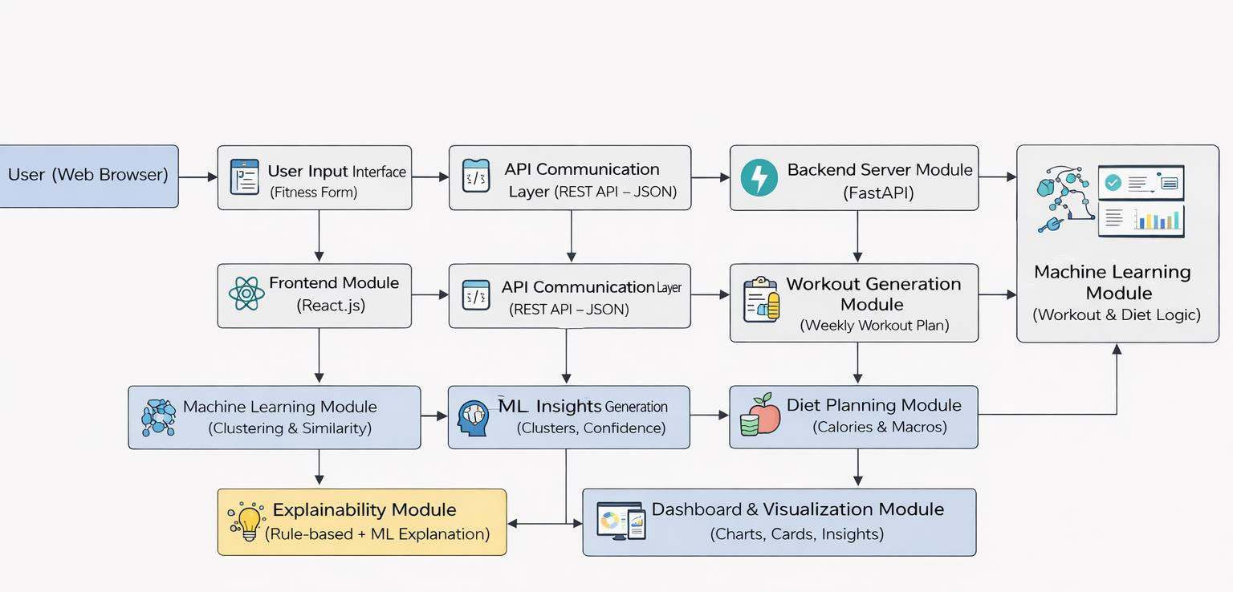

Figure 3.1: Project Architecture of A Rule Based Approach for Fitness Recommendation System

DESCRIPTION

Input Data : The project uses user profile data collected through a web-based fitness assessment form. The input includes age, gender, height, weight, fitness goal, experience level, available workout time, equipment access, diet preference, adherence level, and recovery capability. No image, video, or sensor-based data is used.

Reading Data: The input data is captured through a React-based frontend and transmitted to the backend using RESTful API calls in JSON format. The FastAPI backend validates the data using Pydantic models to ensure correctness, range constraints, and consistency before further processing.

Feature Extraction : Derived features such as Body Mass Index (BMI), calorie requirements, macronutrient targets, and workload capacity are computed using domain- specific formulas and fitness guidelines. These engineered features act as structured inputs for both rule-based logic and machine learning–assisted analysis.

Pattern Analysis : A lightweight machine learning module performs clustering and similarity analysis on user profiles to identify patterns among individuals with similar fitness characteristics. This step is used to adjust recommendation intensity and provide contextual insights rather than replace expert-defined rules.

R u l e - B a s e d R e c o m m e n d a t i o n E n g i n e : A deterministic rule-based engine generates personalized workout and diet plans using predefined fitness rules, expert logic, and constraints. These rules ensure safe, consistent, and explainable outputs, making the system suitable for academic evaluation and real-world deployment.

Explainability and Insight Generation : The system produces explainable outputs, including rule-based decisions and ML-assisted insights, clearly stating why a particular training mode, calorie target, or diet plan was selected. This enhances transparency and user trust, unlike black-box deep learning models.

O u t pu t Ge n e r a t i o n : The final output consists of a weekly workout plan, weekly diet plan, profile summary, training mode, ML insights, and explainability reports, which are returned to the frontend and displayed in a structured dashboard.

Feedback : User input parameters can be modified at any time to regenerate recommendations instantly. This interactive feedback loop allows dynamic personalization without requiring model retraining or large datasets.

Performance Characteristics : The system emphasizes consistency, explainability, and low computational overhead rather than raw prediction accuracy. Since fitness recommendations follow established physiological rules, deterministic outputs ensure reliability across diverse user profiles.

DATA FLOW DIAGRAM

A Data Flow Diagram (DFD) is a graphical representation that illustrates how data flows within a system, showcasing its processes, data stores, and external entities. It is a vital tool in system analysis and design, helping stakeholders visualize the movement of information, identify inefficiencies, and optimize workflows.

A Data Flow Diagram comprises Four primary elements:
- External Entities: Represent sources or destinations of data outside the system.
- Processes: Indicate transformations or operations performed on data.
- Data Flows: Depict the movement of data between components.
- Data Stores: Represent where data is stored within the system.

These components are represented using standardized symbols, such as circles for processes, arrows for data flows, rectangles for external entities, and open-ended rectangles for data stores.

Levels of DFD:

DFDs are structured hierarchically:

- Level 0 (Context Diagram): Shows the overall flow between the user, the fitness recommendation system, and the generated outputs.

- Level 1: Breaks the system into major processes such as profile analysis, ML- assisted clustering, rule-based recommendation, and output generation.

- Level 2: Further details internal processes like BMI calculation, calorie estimation, workout rule selection, and explainability generation.

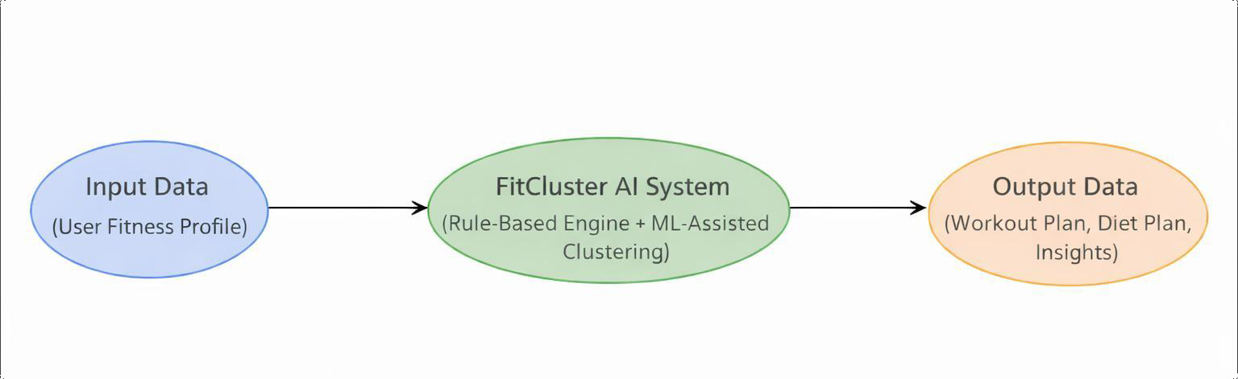

Figure 3.2: Dataflow Diagram of A Rule Based Approach for Fitness Recommendation System

IMPLEMENTATION

IMPLEMENTATION

The implementation phase of a project involves executing the planned strategies and tasks. It requires meticulous coordination, resource allocation, and monitoring to ensure that objectives are met efficiently. Effective implementation is crucial for achieving project goals and delivering expected outcomes within the set timeline and budget constraints.

ALGORITHMS USED

Rule-Based Fitness Decision Engine
Rule-based algorithms form the core decision-making layer of the system. These rules are designed using exercise science principles, fitness guidelines, and nutritional standards.
How the Rule-Based Engine Works:
User inputs such as age, gender, height, weight, fitness goal, experience level, equipment availability, recovery level, and adherence are evaluated. Predefined logical rules map user profiles to:
    - Training intensity
    - Workout split (full-body / push-pull / upper-lower)
    - Exercise selection
    - Rest periods and volume

Advantages of Rule-Based Algorithm:
    - Highly interpretable and explainable
    - No dependency on large datasets
    - Immediate and consistent outputs
    - Ideal for safety-critical domains like fitness

Limitations:
    - Requires careful rule design and validation
    - Less adaptive without auxiliary learning mechanisms.

BMI and Health Metric Computation Algorithm
A deterministic algorithm is used to compute Body Mass Index (BMI) and related health categories.

Algorithm Logic:
BMI = Weight (kg) / (Height (m))²

Categorized into:
    - Underweight
    - Normal
    - Overweight
    - Obese

These metrics influence:
    - Calorie targets
    - Training intensity
    - Exercise selection constraints

Advantages:
    - Clinically accepted formula
    - Computationally lightweight
    - Highly reliable and standardized.

Hybrid Decision Integration Strategy
The final recommendation is produced using a hybrid integration algorithm.
Integration Flow:
    - Rule-based engines generate primary workout and diet plans
    - ML clustering provides adjustment signals
    - Final recommendations are validated against safety constraints
    - Explainability data is generated for transparency

Advantages:
      - Transparent calorie and macro allocation
      - Easy validation by nutrition guidelines
      - Safer than black-box diet generation models

Rule-Based Diet Recommendation Algorithm
The diet planning module uses nutrition-based rules combined with metabolic calculations.

Key Calculations:
- BMR (Basal Metabolic Rate) using standard equations
- TDEE (Total Daily Energy Expenditure) based on activity level
- Macro-nutrient distribution (Protein, Carbohydrates, Fats)
- Diet Personalization Factors
- Diet preference (Vegetarian / Non-Vegetarian)
- Fitness goal (Fat loss, Muscle gain, General fitness)
- Weekly adherence level

Advantages:
- Transparent calorie and macro allocation
- Easy validation by nutrition guidelines
- Safer than black-box diet generation models

Lightweight Machine Learning Clustering Algorithm
While the system is not deep-learning dependent, it integrates unsupervised machine learning to enhance personalization.
Clustering Purpose:
- Group users with similar fitness profiles
- Identify behavioral and physiological similarity patterns
- Provide ML-assisted insights, not final decisions

Algorithm Characteristics:
Works on structured numerical features
  - No image or sensor data required Produces:
  - Cluster label
  - Confidence score
  - Similar user profiles count

Role of ML in the System:
  - Acts as a supporting intelligence layer
  - Does not override rule-based decisions
  - Improves adaptability without compromising explainability

SAMPLE CODE

from fastapi import FastAPI, APIRouter from dotenv import load_dotenv
from starlette.middleware.cors import CORSMiddleware from motor.motor_asyncio import AsyncIOMotorClient import os
import logging
from pathlib import Path
from pydantic import BaseModel, Field from typing import Optional
import uuid
from datetime import datetime, timezone

# Local engine imports
from workout_engine import generate_weekly_workout from diet_engine import generate_weekly_diet
from ml_engine import run_ml_analysis

ROOT_DIR = Path( file ).parent
load_dotenv(ROOT_DIR / '.env')

# MongoDB connection
#mongo_url = os.environ['MONGO_URL'] #client = AsyncIOMotorClient(mongo_url) #db = client[os.environ['DB_NAME']]

app = FastAPI(title="FitCluster AI", version="1.0.0") api_router = APIRouter(prefix="/api")

# ──────MODELS─────── class UserProfile(BaseModel):
age: int = Field(ge=16, le=80)
gender: str = Field(pattern="^(male|female)$") height: float = Field(ge=100, le=250)
weight: float = Field(ge=30, le=200)
fitness_goal: str = Field(pattern="^(muscle_gain|fat_loss|general_fitness)$") experience_level: str = Field(pattern="^(beginner|intermediate|advanced)$") available_time: str = Field(pattern="^(20-30|40-50|60\\+)$")
equipment: str = Field(pattern="^(home|gym)$")
diet_preference: str = Field(pattern="^(vegetarian|non_vegetarian)$") weekly_adherence: int = Field(ge=0, le=100)
recovery_level: str = Field(pattern="^(low|medium|high)$")

# ─── ENDPOINTS─── @api_router.get("/health") async def health_check():
return {"status": "healthy", "service": "FitCluster AI"}

@api_router.post("/recommend")
async def generate_recommendation(profile: UserProfile): """
Main recommendation endpoint.
- Runs ML analysis (clustering + similarity)
- Generates workout plan (rule-based + ML adjustments)
- Generates diet plan (rule-based)
- Compiles explainability data
"""
user_data = profile.model_dump()

# Calculate BMI
bmi = round(user_data["weight"] / ((user_data["height"] / 100) ** 2), 1) bmi_category = (
"Underweight" if bmi < 18.5 else "Normal" if bmi < 25 else "Overweight" if bmi < 30 else "Obese"
)

# Step 1: ML Analysis
ml_insights = run_ml_analysis(user_data)

# Step 2: Generate workout plan with ML adjustments workout_result = generate_weekly_workout(user_data,
ml_insights["adjustments"])

# Step 3: Generate diet plan
diet_result = generate_weekly_diet(user_data)

# Step 4: Compile rule-based explainability rule_explanations = [
{
"decision": f"Training Mode: {workout_result['mode_label']}", "reason": workout_result["mode_explanation"],
"type": "rule"
},
{
"decision": f"Calorie Target: {diet_result['target_calories']} kcal/day",
"reason": diet_result["explanation"], "type": "rule"
},

{
"decision": f"Equipment: {user_data['equipment'].title()} workout pool
selected",
"reason": f"Exercise library filtered for {user_data['equipment']} equipment availability",
"type": "rule"
},
]

# Step 5: Store user profile in MongoDB for future clustering user_record = {
"id": str(uuid.uuid4()), "profile": user_data, "bmi": bmi,
"cluster_id": ml_insights["cluster_id"], "cluster_label": ml_insights["cluster_label"], "timestamp": datetime.now(timezone.utc).isoformat(),
}
#await db.user_profiles.insert_one(user_record)

# Build response (exclude MongoDB _id) response = {
"user_id": user_record["id"], "profile_summary": {
"bmi": bmi,
"bmi_category": bmi_category, "target_calories": diet_result["target_calories"],
"target_protein": diet_result["macros"]["protein"], "target_carbs": diet_result["macros"]["carbs"], "target_fat": diet_result["macros"]["fat"],
},

"training_mode": {
"mode": workout_result["mode"], "label": workout_result["mode_label"],
"explanation": workout_result["mode_explanation"],
},
"weekly_workout_plan": workout_result["weekly_plan"], "weekly_diet_plan": diet_result["weekly_diet"], "diet_summary": {
"bmr": diet_result["bmr"], "tdee": diet_result["tdee"],
"target_calories": diet_result["target_calories"], "macros": diet_result["macros"],
},

"ml_insights": {
"cluster_id": ml_insights["cluster_id"], "cluster_label": ml_insights["cluster_label"],
"cluster_description": ml_insights["cluster_description"], "cluster_recommendation": ml_insights["cluster_recommendation"], "confidence": ml_insights["confidence"],
"feature_importance": ml_insights["feature_importance"], "similarity_score": ml_insights["similarity"]["average_similarity"], "similar_profiles_count":
len(ml_insights["similarity"]["top_similar_indices"]),
},
"explainability": {
"rule_based_decisions": rule_explanations,
"ml_assisted_insights": ml_insights["ml_explanations"],
},
}

return response

# Include router & middleware app.include_router(api_router)

app.add_middleware( CORSMiddleware, allow_credentials=True,
allow_origins=os.environ.get('CORS_ORIGINS', '*').split(','), allow_methods=["*"],
allow_headers=["*"],
)

logging.basicConfig(level=logging.INFO, format='%(asctime)s - %(name)s -
%(levelname)s - %(message)s')
logger = logging.getLogger( name )

#@app.on_event("shutdown") #async def shutdown_db_client():
# client.close()

# ───-FEATURE ENCODING ───
GOAL_MAP = {"muscle_gain": 0, "fat_loss": 1, "general_fitness": 2}
EXPERIENCE_MAP = {"beginner": 0, "intermediate": 1, "advanced": 2}
RECOVERY_MAP = {"low": 0, "medium": 1, "high": 2}
EQUIPMENT_MAP = {"home": 0, "gym": 1}
TIME_MAP = {"20-30": 0, "40-50": 1, "60+": 2}
def create_feature_vector(user_data):
"""Convert user input into a numerical feature vector."""
bmi = user_data["weight"] / ((user_data["height"] / 100) ** 2) return np.array([
user_data["age"],

def train_and_predict(user_vector): """
Train K-Means on synthetic data and predict cluster for new user. Returns cluster info and model details.
"""
scaler = StandardScaler()
scaled_data = scaler.fit_transform(SYNTHETIC_DATA) scaled_user = scaler.transform(user_vector)

# K-Means clustering with 6 personas
kmeans = KMeans(n_clusters=6, random_state=42, n_init=10) kmeans.fit(scaled_data)

# Predict user cluster
cluster_id = int(kmeans.predict(scaled_user)[0])

# Calculate distances to all centroids for confidence distances = kmeans.transform(scaled_user)[0] min_dist = distances[cluster_id]
confidence = max(0.0, min(1.0, 1.0 - (min_dist / (np.max(distances) + 1e-8))))

return cluster_id, confidence, scaled_data, scaled_user, kmeans if cluster_id == 1: # Inconsistent Beginners
adjustments["simplify_movements"] = True adjustments["notes"].append(
"Cluster pattern: Inconsistent beginners benefit from simplified routines"
)
elif cluster_id == 3: # Recovery-Prone adjustments["force_recovery"] = True adjustments["notes"].append(
"Cluster pattern: Recovery-prone users benefit from reduced volume"
)

elif cluster_id == 4: # Advanced Athletes if adherence >= 75:
adjustments["boost_volume"] = True adjustments["notes"].append(
"Cluster pattern: Advanced athletes with high adherence respond to
increased volume"
)
elif cluster_id == 5: # Fat Loss Focused adjustments["add_conditioning"] = True adjustments["notes"].append(
"Cluster pattern: Fat-loss focused users benefit from additional conditioning"
)

return adjustments
# ────── MAIN ML ANALYSIS─────── def run_ml_analysis(user_data):

# Create feature vector
user_vector = create_feature_vector(user_data)

# Train and predict
cluster_id, confidence, scaled_data, scaled_user, kmeans = train_and_predict(user_vector)

# Get persona info
persona = CLUSTER_PERSONAS.get(cluster_id, {
"label": "Unknown",
"description": "Unable to determine cluster", "recommendation": "Default balanced approach"
})

ml_explanations = [
{
"insight": f"User classified as '{persona['label']}' (Cluster
{cluster_id})",
"reason": f"Feature vector analysis yielded {confidence:.0%}
confidence match with cluster centroid",
"type": "ml"
},
{
"insight": f"Top similarity score: {similarity['average_similarity']:.0%}
with {len(similarity['top_similar_indices'])} similar profiles",
"reason": "Cosine similarity computed across all stored user feature vectors",
"type": "ml"
},
]

for note in adjustments["notes"]: ml_explanations.append({
"insight": note,
"reason": "Pattern discovered through unsupervised learning on user clusters",
"type": "ml"
})

sorted_features = sorted(feature_importance.items(), key=lambda x: x[1], reverse=True)
top_features = sorted_features[:3]
ml_explanations.append({
"insight": f"Top influencing features: {', '.join(f[0] for f in top_features)}", "reason": "Feature importance derived from distance to cluster centroid
per dimension",
"type": "ml"

return {
"cluster_id": cluster_id, "cluster_label": persona["label"],
"cluster_description": persona["description"], "cluster_recommendation": persona["recommendation"], "confidence": round(confidence, 3), "feature_importance": feature_importance,
"similarity": similarity, "adjustments": adjustments, "ml_explanations": ml_explanations,
}
class FitClusterAPITester:
def init (self, base_url="https://fitcluster-ai.preview.emergentagent.com"): self.base_url = base_url
self.tests_run = 0
self.tests_passed = 0 self.failed_tests = []

def log_test(self, name, success, details=""): """Log test results"""
self.tests_run += 1 if success:
self.tests_passed += 1 print(f"✅ {name} - PASSED")
else:
self.failed_tests.append({"name": name, "details": details}) print(f"❌ {name} - FAILED: {details}")
def test_health_endpoint(self):
try:
response = requests.get(f"{self.base_url}/api/health", timeout=10) if response.status_code == 200:

data = response.json()
if data.get("status") == "healthy" and "FitCluster AI" in data.get("service", ""):
self.log_test("Health Check", True) return True
else:
self.log_test("Health Check", False, f"Invalid response data: {data}")
else:
self.log_test("Health Check", False, f"Status code:
{response.status_code}") except Exception as e:
self.log_test("Health Check", False, f"Exception: {str(e)}") return False

try:

response = requests.post( f"{self.base_url}/api/recommend", json=valid_payload,
headers={"Content-Type": "application/json"}, timeout=30

)

if response.status_code == 200: data = response.json() required_fields = [
"user_id", "profile_summary", "training_mode", "weekly_workout_plan", "weekly_diet_plan", "ml_insights", "explainability"
]
def test_workout_plan_structure(self):
"""Test workout plan structure in detail""" if not hasattr(self, 'recommendation_data'):
return False

try:
workout_plan = self.recommendation_data.get("weekly_workout_plan", [])

# Check 7 days
if len(workout_plan) != 7:
self.log_test("Workout Plan Structure", False, f"Expected 7 days, got
{len(workout_plan)}")
return False

# Check each day structure for day in workout_plan:
required_fields = ["day", "day_name", "workout_name", "is_rest_day", "exercises", "explanation"]
missing_fields = [field for field in required_fields if field not in day] if missing_fields:
self.log_test("Workout Plan Structure", False, f"Day {day.get('day', '?')} missing: {missing_fields}")
return False

# Check exercises structure for non-rest days if not day["is_rest_day"]:
if not day["exercises"]:
self.log_test("Workout Plan Structure", False, f"Day {day['day']} has no exercises but is not rest day")
return False

for ex in day["exercises"]:
ex_required = ["id", "name", "sets", "reps", "video_id",
"muscle_group"]
if ex_missing:
self.log_test("Workout Plan Structure", False, f"Exercise missing:
{ex_missing}")

except Exception as e:
self.log_test("Workout Plan Structure", False, f"Exception: {str(e)}") return False

def test_diet_plan_structure(self):
"""Test diet plan structure in detail"""
if not hasattr(self, 'recommendation_data'):
self.log_test("Diet Plan Structure", False, "No recommendation data available")
return False

try:
diet_plan = self.recommendation_data.get("weekly_diet_plan", [])

# Check 7 days
if len(diet_plan) != 7:
self.log_test("Diet Plan Structure", False, f"Expected 7 days, got
{len(diet_plan)}")
return False

# Check each day structure for day in diet_plan:
required_fields = ["day", "day_name", "meals", "total_calories", "total_protein"]
missing_fields = [field for field in required_fields if field not in day] if missing_fields:
self.log_test("Diet Plan Structure", False, f"Diet day {day.get('day',
'?')} missing: {missing_fields}")
return False

for meal in day["meals"]:
meal_required = ["meal_type", "food"]
meal_missing = [field for field in meal_required if field not in meal] if meal_missing:
self.log_test("Diet Plan Structure", False, f"Meal missing:
{meal_missing}")
return False

# Check food structure food = meal["food"]
food_required = ["id", "name", "calories", "protein", "carbs", "fat"] food_missing = [field for field in food_required if field not in food] if food_missing:
self.log_test("Diet Plan Structure", False, f"Food missing:
{food_missing}")
return False

self.log_test("Diet Plan Structure", True) return True

except Exception as e:
self.log_test("Diet Plan Structure", False, f"Exception: {str(e)}") return False
def test_ml_insights_structure(self): """Test ML insights structure"""
if not hasattr(self, 'recommendation_data'):
self.log_test("ML Insights Structure", False, "No recommendation data
available")
return False

5. RESULTS & DISCUSSION

RESULTS & DISCUSSION

The following screenshots showcase the results of our project, highlighting key features and functionalities. These visual representations provide a clear overview of how the system performs under various conditions, demonstrating its effectiveness and user interface. The screenshots serve as a visual aid to support the project's technical and operational achievements.

GUI/Main Interface :

The Graphical User Interface (GUI) of FitCluster AI is designed to provide a simple and interactive platform for users to receive personalized fitness and diet recommendations. The interface is implemented using React, enabling a responsive and user-friendly experience.

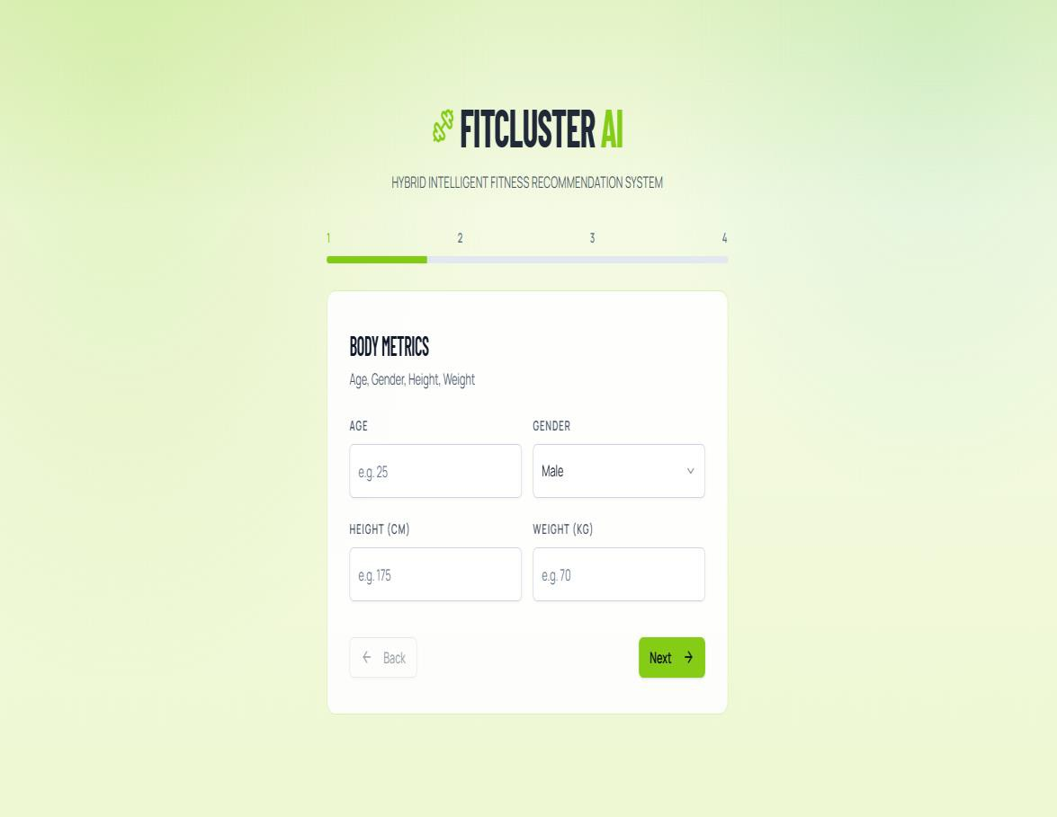

Figure 5.1 : GUI/Main Interface of FIT CLUSTER AI- A Hybrid Intelligence of a Fitness Recommendation System

Sample User Input :

To generate personalized recommendations, the system requires users to provide basic health and lifestyle information. These inputs are collected through the user interface and sent to the backend system for processing.
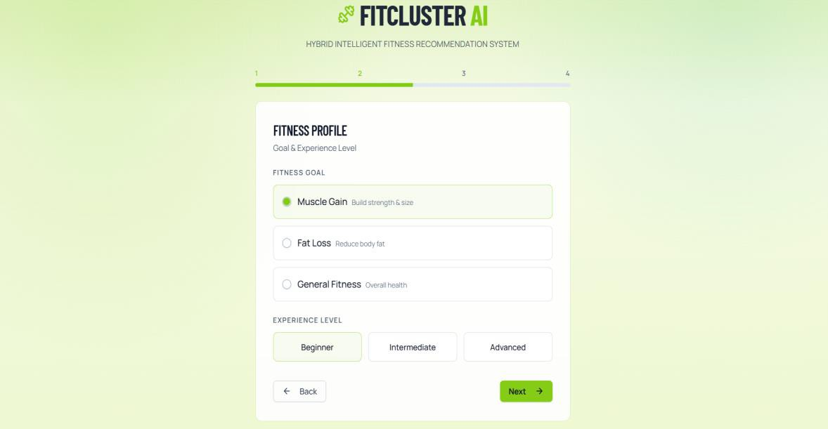

Figure 5.2 : Fitness profile Image of FIT CLUSTER AI- A Hybrid Intelligence of a Fitness Recommendation System
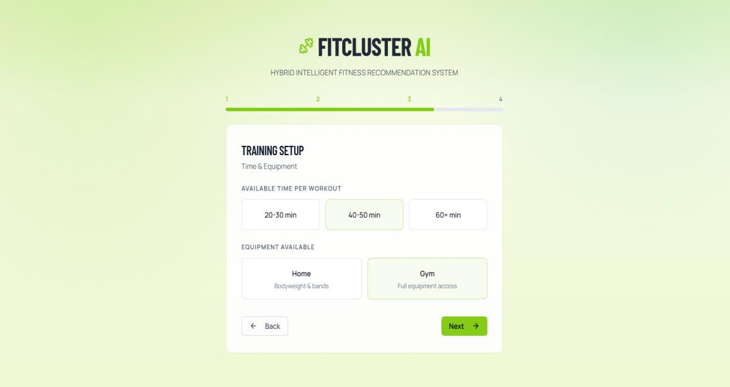

Figure 5.3 : Training setup Image of FIT CLUSTER AI- A Hybrid Intelligence of a Fitness Recommendation System

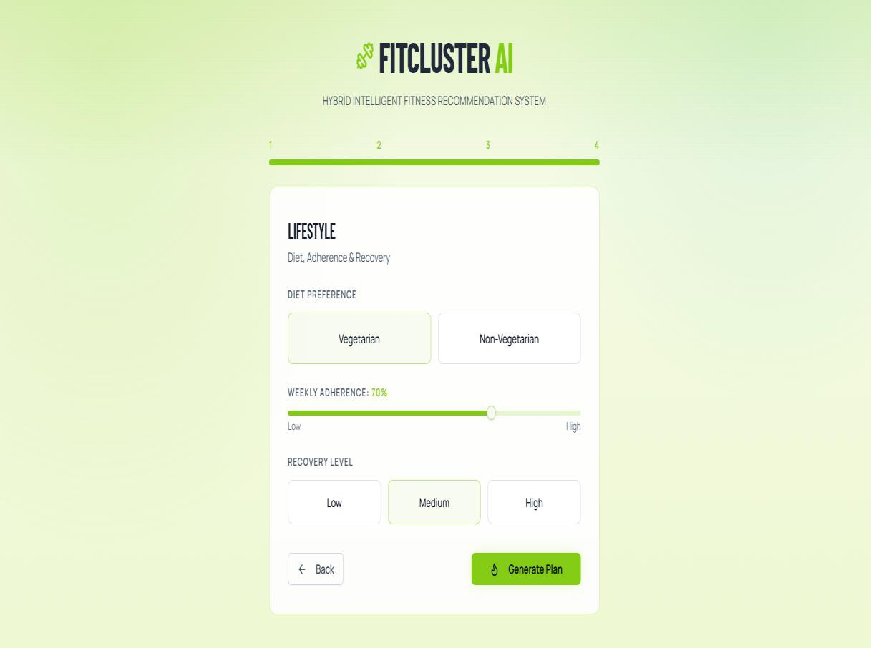

Figure 5.4 : Lifestyle Image of FIT CLUSTER AI- A Hybrid Intelligence of a Fitness Recommendation System

Knowledge Base / Data Storage:

The data required for generating recommendations is stored and managed using MongoDB, a NoSQL database that allows flexible storage of structured and semi- structured data. MongoDB is used in the system to store information such as diet plans, workout plans, fitness categories, and nutritional guidelines.

When a user enters personal information through the interface, the data is sent to the backend server where it is processed by the recommendation engine. The system calculates important health metrics such as Body Mass Index (BMI) and determines the user’s fitness category. Based on this category and the selected fitness goal, the system retrieves appropriate diet and workout recommendations from the MongoDB database.

One of the key metrics used in the system is the Body Mass Index (BMI), which helps categorize users based on their body weight relative to their height. The BMI categories used by the system are shown below.

BMI Range | Category
< 18.5 | Underweight
18.5 – 24.9 | Normal
25 – 29.9 | Overweight
≥ 30 | Obese

Table 5.3 : BMI range table category of FIT CLUSTER AI - A Hybrid
Intelligence of Fitness Recommendation System

Generated Diet Plan Output :

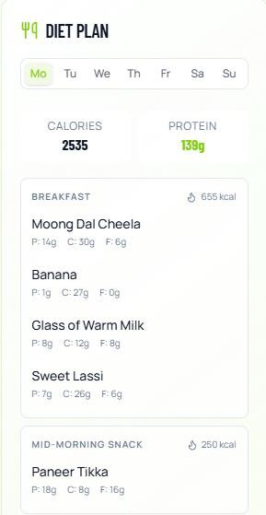
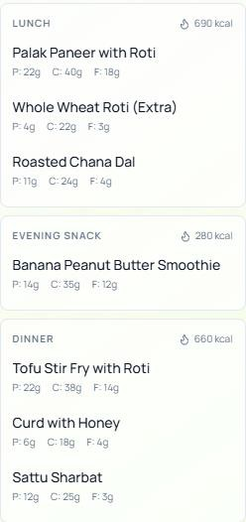
In below screen, propose algorithm evaluating playing video and then detecting and classifying it as ‘Inappropriate Content’.
Figure 5.5 : Generated Diet plan Image of FIT CLUSTER AI- A Hybrid Intelligence of a Fitness Recommendation System

Generated Workout Plan Output :
In addition to diet recommendations, the system also provides a structured workout plan designed to help users achieve their fitness goals.

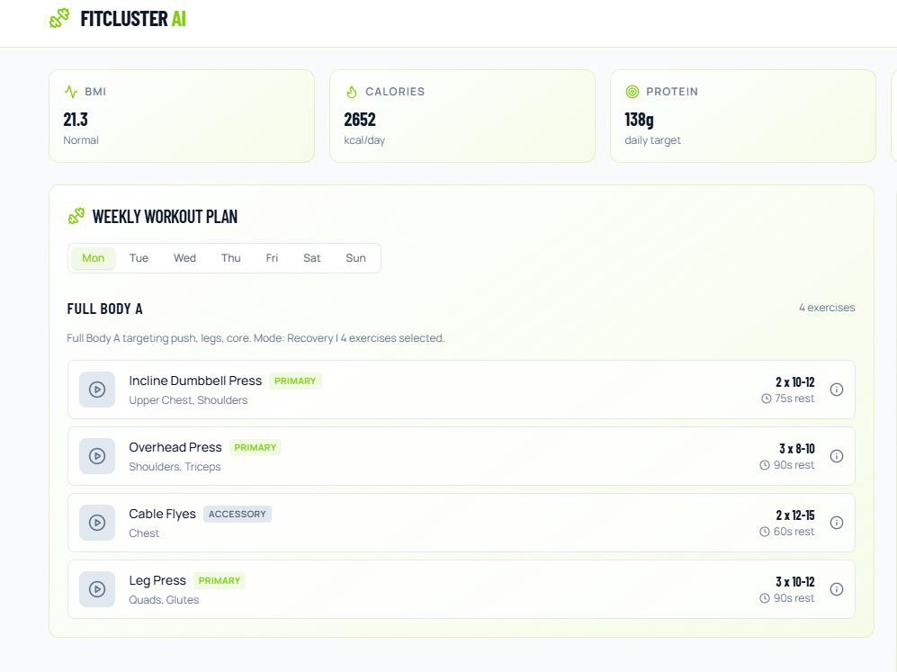

Figure 5.6 : Generated Weekly workout plan Image of FIT CLUSTER AI - A Hybrid Intelligence of a Fitness Recommendation System

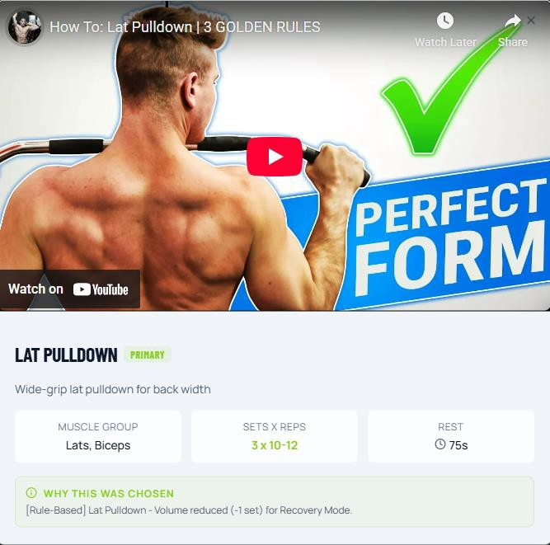

Figure 5.7 : workout Form and video of FIT CLUSTER AI - A Hybrid Intelligence of a Fitness Recommendation System

Evaluation of Recommendation Results :
The FitCluster AI system incorporates lightweight machine learning techniques to assist the rule-based recommendation engine in generating meaningful insights from user health data. The purpose of this component is not to replace the rule-based system but to enhance the analysis of user metrics such as Body Mass Index (BMI), activity level, and fitness goals.

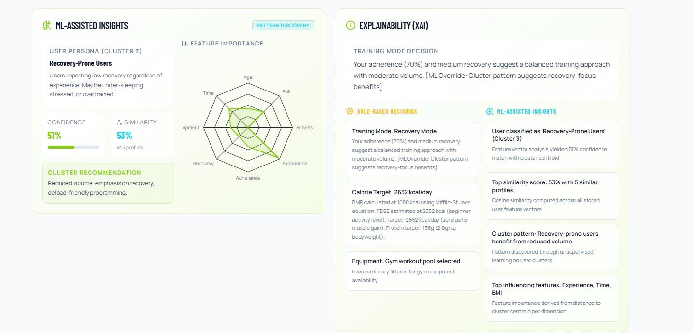

Figure 5.8 : ML assisted insights and Explainability image of FIT CLUSTER AI - A Hybrid Intelligence of a Fitness Recommendation System

Evaluation Metrics :
The overall performance of the FitCluster AI system was evaluated by testing the application with multiple input scenarios representing different user profiles. The system successfully generated appropriate diet and workout recommendations based on variations in age, BMI category, activity level, and fitness goals.

The integration of a responsive frontend and a lightweight backend ensures that the system processes user inputs efficiently and delivers recommendations with minimal delay. The modular architecture of the system allows the frontend interface to communicate smoothly with the backend recommendation engine through API requests.

The use of a structured knowledge base combined with ML-assisted analysis enables the system to maintain both accuracy and interpretability. Recommendations remain aligned with standard fitness and nutrition guidelines while still adapting to individual user inputs.

Another advantage of the system is its scalability. Because the recommendation data is stored in a database, new diet plans, exercise routines, and fitness categories can be added easily without modifying the core system logic.

VALIDATION

VALIDATION

INTRODUCTION
The validation phase evaluates the functionality and reliability of the FitCluster AI system. The purpose of validation is to verify that the system generates appropriate diet and workout recommendations based on different user inputs.

The system was tested with multiple input scenarios representing users with different age groups, body measurements, activity levels, and fitness goals. These tests help confirm that the recommendation engine correctly processes user data and produces meaningful outputs aligned with established fitness guidelines.

Validation ensures that the system performs as expected and that the recommendations generated are logically consistent with the user's health profile.

TEST CASES

Test Case | Input Condition | Expected Output
TC1 | BMI > 30, Weight Loss Goal | Calorie deficit diet + cardio workout
TC2 | BMI Normal, Muscle Gain | Protein rich diet + strength training
TC3 | Underweight BMI | High calorie diet + moderate strength
TC4 | Sedentary lifestyle | Beginner workout plan

Table 6.2 : BMI rule table of FIT CLUSTER AI - A Hybrid Intelligence of Fitness Recommendation System

7. CONCLUSION & FUTURE ASPECTS

CONCLUSION & FUTURE ASPECTS

PROJECT CONCLUSION

The FitCluster AI system was developed to provide personalized fitness and diet recommendations based on user health metrics and lifestyle information. The system collects user inputs such as age, height, weight, activity level, and fitness goals, and processes this information to generate appropriate workout and nutrition plans.

The application integrates a user-friendly frontend interface developed using React with a backend recommendation engine implemented using FastAPI. The system also uses MongoDB to store structured information related to workout routines, diet plans, and fitness categories.

The recommendation engine combines rule-based logic with lightweight machine learning assistance to analyze user health indicators such as Body Mass Index (BMI) and activity level. Based on this analysis, the system generates personalized fitness guidance that helps users make informed decisions about their diet and exercise routines.

The results obtained during system testing demonstrate that the application is capable of producing consistent and meaningful recommendations for different user profiles. The modular design of the system ensures that the application is efficient, scalable, and easy to maintain.

Overall, the FitCluster AI system provides a practical solution for personalized fitness guidance by combining intelligent data analysis with an accessible and interactive interface.

FUTURE ASPECTS

Although the current version of the FitCluster AI system provides useful personalized recommendations, several improvements can be made in future versions to enhance its capabilities.

One possible enhancement is the integration of advanced machine learning models that can learn from larger datasets and improve the accuracy of fitness recommendations over time. This would allow the system to adapt more effectively to different user health profiles and preferences.

Another future improvement could involve integrating wearable device data such as heart rate, step count, and daily activity levels. This would allow the system to monitor real-time user activity and provide more dynamic and accurate fitness suggestions.

The system could also be expanded to include additional features such as progress tracking, personalized goal monitoring, and adaptive workout planning based on user performance. Mobile application support could further improve accessibility and allow users to receive recommendations on their smartphones.

In the future, FitCluster AI could also incorporate more detailed nutritional databases and meal planning tools to provide comprehensive dietary guidance.

With these enhancements, the system has the potential to evolve into a more intelligent and comprehensive personal fitness assistant capable of supporting users in achieving their long-term health and wellness goals.

8. BIBLIOGRAPHY

BIBLIOGRAPHY

REFERENCES

    - World Health Organization, “Body Mass Index – BMI Classification,” WHO Guidelines. Available: https://www.who.int

    - Centers for Disease Control and Prevention, “About Adult BMI,” CDC Health Guidelines. Available: https://www.cdc.gov

    - American College of Sports Medicine, ACSM’s Guidelines for Exercise Testing and Prescription, 10th ed., Philadelphia: Lippincott Williams & Wilkins, 2017.

    - I. Goodfellow, Y. Bengio, and A. Courville, Deep Learning. Cambridge, MA: MIT Press, 2016.

    - M. Grinberg, Flask Web Development: Developing Web Applications with Python, O’Reilly Media, 2018.

    - Official React Documentation, “React – A JavaScript Library for Building User Interfaces.” Available: https://react.dev

    - FastAPI Documentation, “FastAPI Framework for Building APIs with Python.” Available: https://fastapi.tiangolo.com

    - MongoDB Documentation, “MongoDB: NoSQL Database for Modern
Applications.” Available: https://www.mongodb.com/docs

    - S. Russell and P. Norvig, Artificial Intelligence: A Modern Approach, 3rd ed., Pearson Education, 2010.

    - T. Hastie, R. Tibshirani, and J. Friedman, The Elements of Statistical Learning, Springer, 2009.

    - Waseem, Z., & Hovy, D. (2016). Detecting offensive language in social media to protect adolescent online safety. Proceedings of the 2016 Conference of the North American Chapter of the Association for Computational Linguistics (NAACL).

    - Joulin, A., Grave, E., Bojanowski, P., & Mikolov, T. (2017). Bag of tricks for efficient text classification. Proceedings of the 15th Conference of the European Chapter of the Association for Computational Linguistics (EACL).

    - Devlin, J., Chang, M. W., Lee, K., & Toutanova, K. (2019). BERT: Pre-training of deep bidirectional transformers for language understanding. Proceedings of NAACL- HLT.

    - Vaswani, A., Shazeer, N., Parmar, N., Uszkoreit, J., Jones, L., Gomez, A. N., Kaiser, Ł., & Polosukhin, I. (2017). Attention is all you need. Advances in Neural Information Processing Systems (NeurIPS).

    - Zhao, X., Xia, L., & Tang, J. (2019). Deep reinforcement learning for recommender systems: A survey and new perspectives. arXiv preprint arXiv:1901.01380.

GITHUB LINK

https://github.com/shashank-boddu/FitClusterAi

